SOLR & Lucene:

Considered 3 xml documents initially,

1. Trump.xm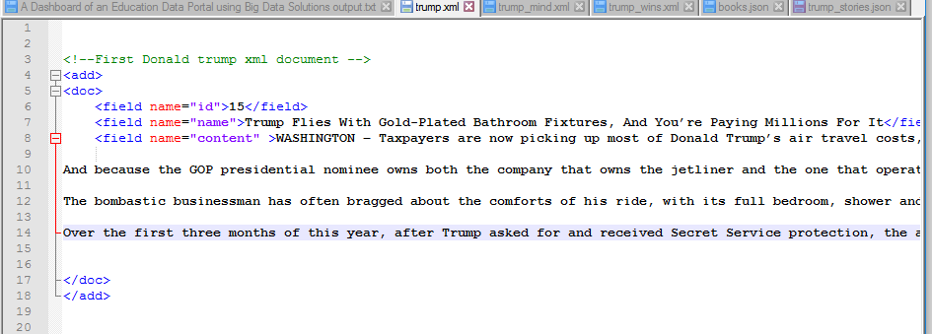
2. Trump_mind

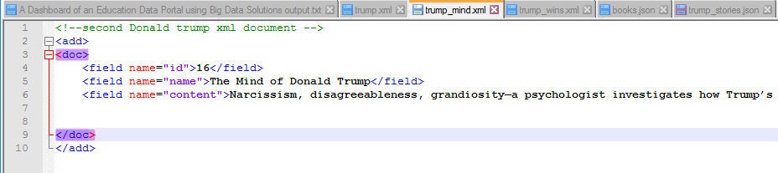

3.trump_wins

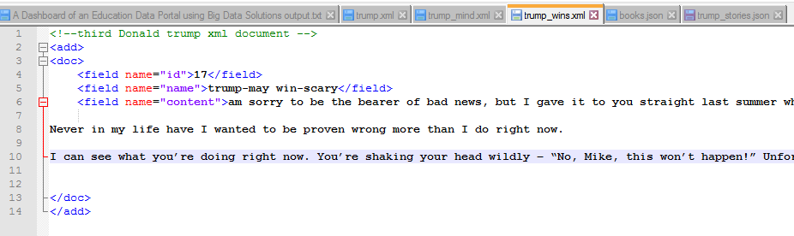

Performed followed queries:

1. dfgdfgfdfgdq: trump, fl:name,id,wt=xml

Observation: Results id and name of the documents which have trump keyword associated with.

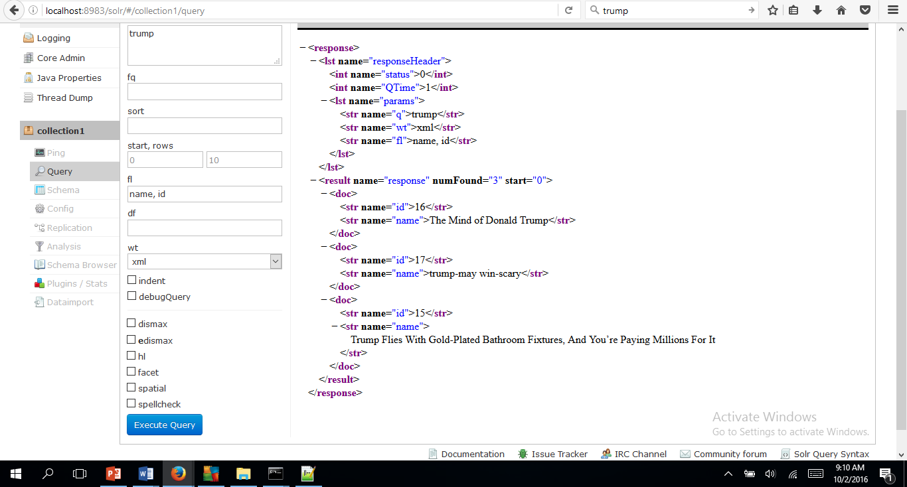

2. q: trump, fl:name,id, sort=id asc wt=xml

Observation: Results are provided in the ascending order of id’s.

1. 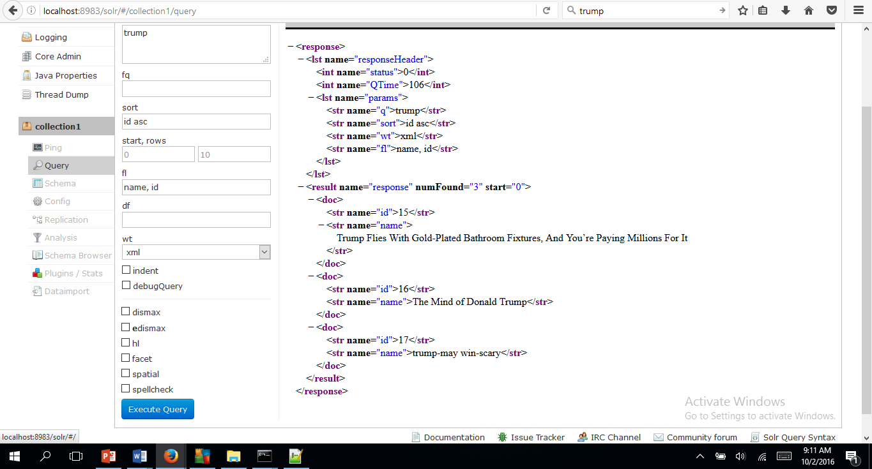

3.unsuccesful uploading of json file

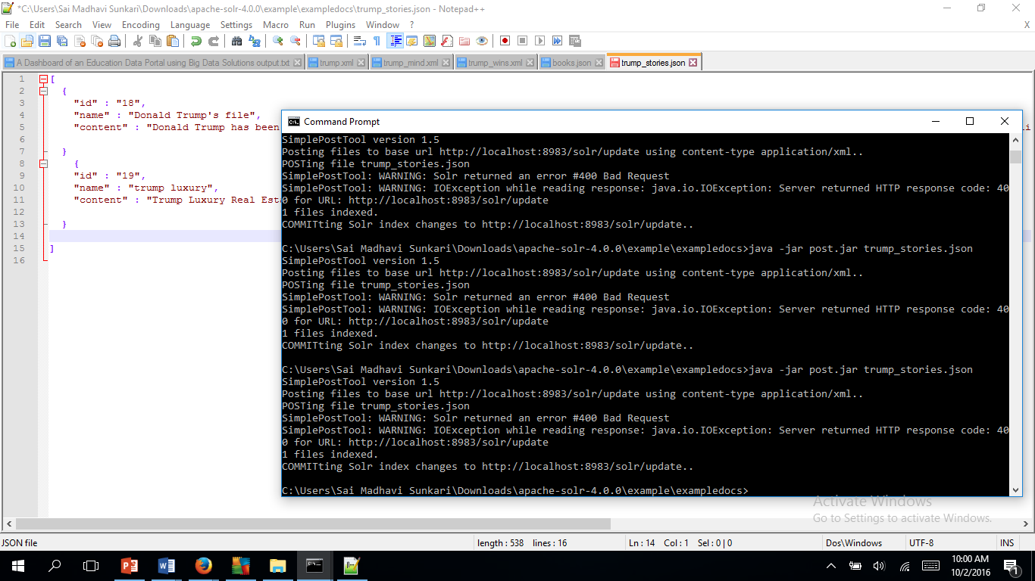

Thought of indexing upon mixed files :xml and json

4.q=trump, fl=id, wt=json

Converts all the results into json format

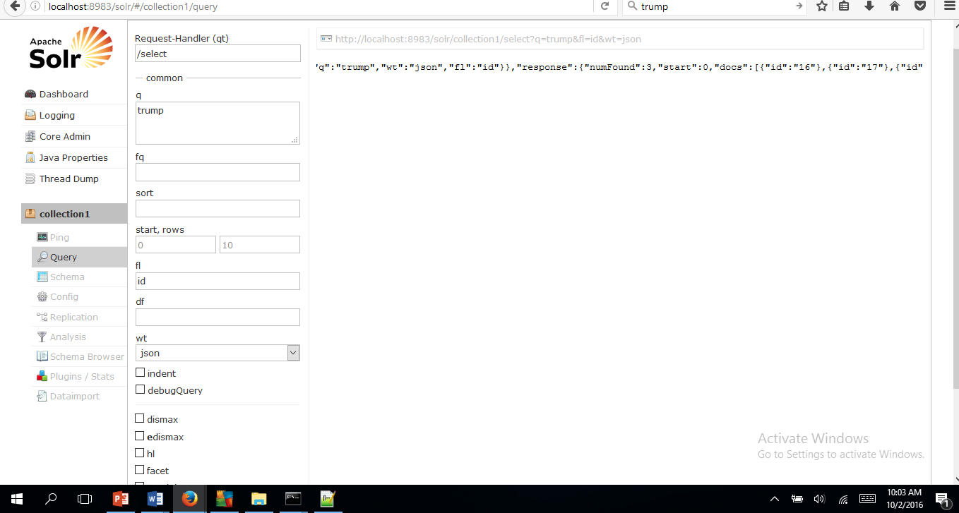

1. q= Narcissism, wt=xml, facet.field=name

Observation: facet has given combination of two documents name as a result under ‘name’ field of facet_fields tag.

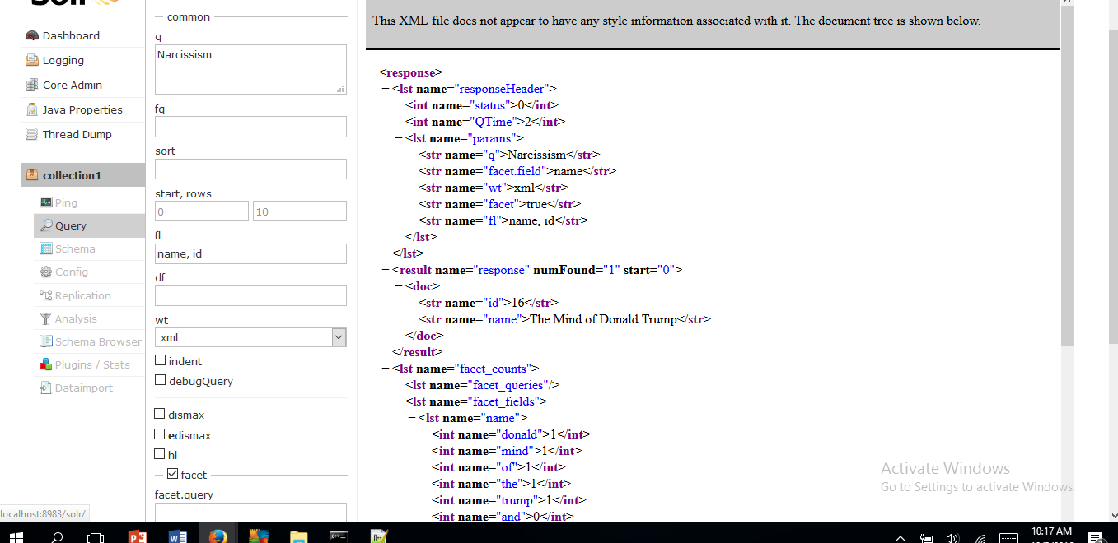

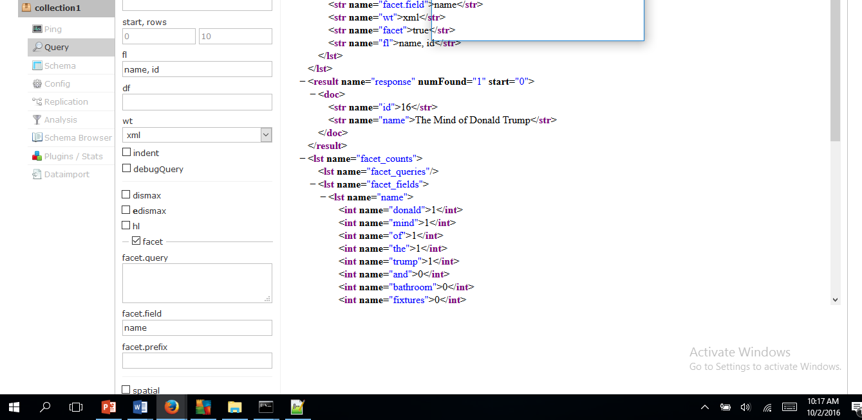

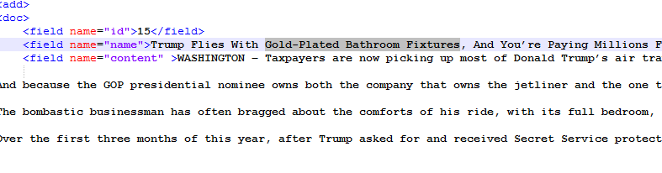

Fig: document : trump.xml

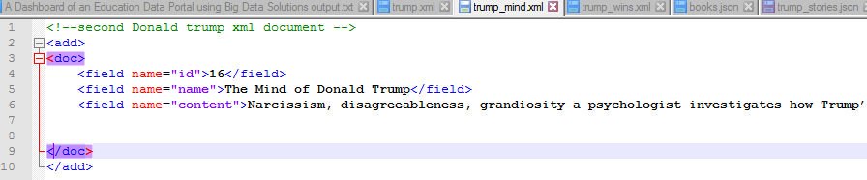

Fig: document : trump_mind.xml